Name Li Jiajun | 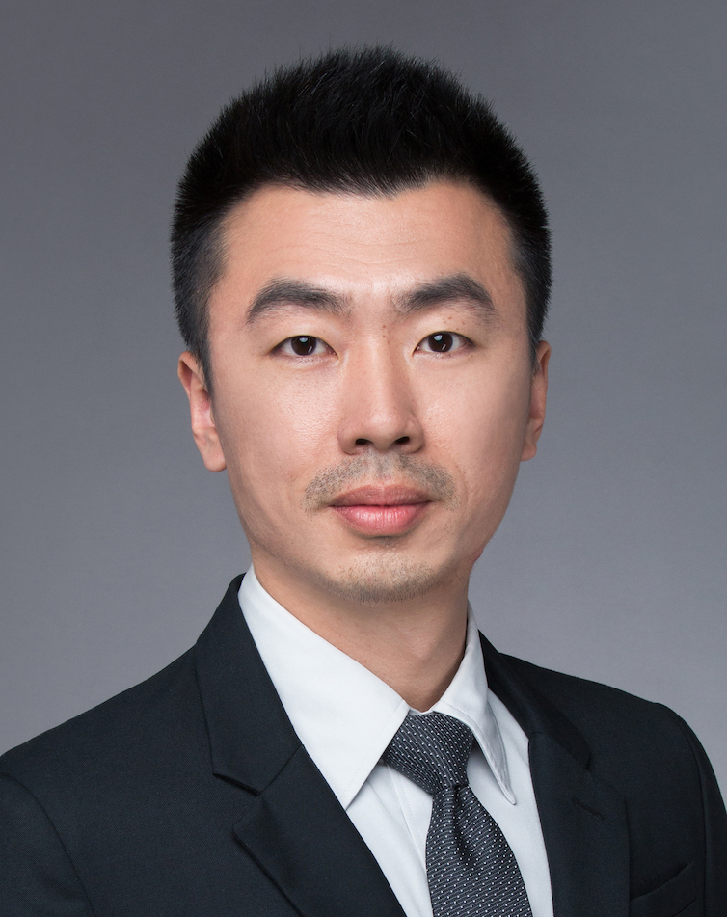
Gender Male
Birthday 1983.12
Location Shanghai
Status Married
Education background
2002.09 – 2006.07.20 Shanghai Maritime University Marine engineering
Major & degree Bachelor in Engineering

Working Experience
2016.02 – Now Planning and Logistics Department Shanghai Volkswagen Powertrain Co.,Ltd
Position Expert of demand & supply resource management
- Lead and manage the team of resource management to achieve the annual objective
- Distribute the mission of team members based on actual situation
- Set the annual aim for team member
- Train the team member
- Demand & forecast
- Regularly analysis the customer forecast, classify the demand level and identify the risks and opportunities in the demand
- Control the backlog plan of key suppliers for balance the demand of production and turnover.
- Setting the production plan with planning team according to the resource status
- Supply chain management
- Capacity management
- Ensure the delivery on time and enough for fulfill the series production
- Enquiry the capacity for supply chain, checking the reply info and make the report annually.
- Take part in the China region regular meeting of resource management (with VGC/SVW/FAW-VW Purchasing & Logistics)
- Control and make the balance between the demand, production plan and resource.
- Risks management
- Track and monitor the supply chain risk, regularly update the critical parts report to company top management team.
- In charge of the “Site Visit Team (SVT)” with Quality, Logistics, Purchasing, visit the supplier to support and solve the problems in house at their plant.
- Support the capacity launching and ramp-up of new project and new supplier. Help the supplier to make the supply chain process.
- Check and make the backlog plan along with the demands fluctuating and cost effectiveness.
- Monitor the environment of supply chain, irregular visit the supplier for checking.
- Set risk enquiry plan, supervise team member to release the info and check the summary report.
- Supply chain operational management
- Arrange team member to make the Supplier KPI (VW-SRS) of supply chain operation.
- Make the supply rating process and define the evaluate KPI range.
- Make the useful communication with PU for ensure the strategy of supply.
- Tracking the operation problems and push to improvement
- Attend the project meeting, make the PR strategy and localization plan with TE, PU, TQ.
- Mold & tooling management
- Making the budget of molds to along the forecast strategy.
- Together with PU, allocate the molds cost (VWPT & FAW-VW), And maintain the cost information into systems.
- Manage all molds as fixed assets and check the checking report from team member.
- Some project experience
- SRS (Supplier Rating System) online implementing project (2016)
Be the responsible person, participated the whole project to ensure the system online on time finally. Also, all the JVs of China region are using this rating system for logistics KPI.
Performance: This system optimizes the level of logistics’ operation. The average KPI rating was be increased from Note 87 (Mar.2016) to Note 92 (Dec. 2016).
- Project of risk of supply chain summary（2016）
Be the responsible person, participated the whole project.
The target of this project is to analysis the data of supplier chain risk from 2009 to 2015. Then try to find some logics in these cases for supplier management in the future.
Performance: For example: "Remark the schedule of risk enquiry plan, added some details in it. Then to decreased the risk parts finally. The quantity of 2016 risk parts was less than the average quantity from 2009 to 2015, about 25%.
2009. 07– 2016.02 Planning and Logistics department Shanghai Volkswagen powertrain Co.,Ltd
Position Officer of demand & supply resource management
- Risk part controlling
Attend the China region risk resource regular meeting, cooperate with VGC, SAIC-VW, FAW-VW LO & BU to discuss the solutions to solve engine supplier chain problem.
Tracking the long-term risk parts for production, delivery and stock level.
- Capacity management of supplier
Visit the supplier plant for risk parts, to find the production process problem on site. Especially for Casting and foundry suppliers.
- The project of Cam raw part localization (2015)
Support to analysis of capacity and gap
This project broken the monopoly of CKD cam in EA211 engine. Also to solve the capacity problem about cam raw part is not enough for VW China in 2015. Finally the new supplier Jiangsu Sunway started to delivery, the PPAP was successful.
Performance: The project got the award of “the key quality achievement”. 2nd class. No. 2016010043

2006. 07– 2009.06 Planning and Logistics Department Shanghai Volkswagen Powertrain Co.,Ltd
Position Local parts disposition
- Release the weekly order for suppliers
- Manage the delivery and operation of suppliers.
- Manage the inventory level along inventory costs and security of supply.
- Release the 12 weeks rolling forecast
- Track the risk parts delivery

Skills & Others

Language Chinese & Shanghainese: Native
English： Fluent in listening; Speaking; Reading; Writing
Certification - Process-Auditor to VDA6.3 Issuing Date：2011,10,21 Shanghai
No：CN/6.3/1011016 Issuing authority：VDA
- Internal Process Auditor Date：2006,8,13 Shanghai
Issuing authority：TÜV
PC ability MS-Office, SAP, ERP
Driving license C1

